Development of a dynamic logistic model for the prediction of PKR to USD exchange rate

Ali Latif
CureMD, Lahore, Pakistan

Abstract – Currency exchange rates have been the center of fiscal and monetary policy discussions in emerging economies. Exchange rate is a vibrant and mega economic metric and has major effects on economic activities including trade, investments and overall growth. With the increasing volatility of currency exchange rates, the subject of exchange rate prediction has gained high importance. In countries like Pakistan, exchange range is affected by multiple agents and it has a direct and swift impact on economic activities. The purpose of this paper is to derive and develop a dynamic logistic model for prediction of USD to PKR exchange rate.
.
I. Introduction
Economic policies of a country have significant impact on the growth and development of the country. These policies combined with multiple other factors such as monetary restrictions, internal debts, external debts, circular debts, balance of payments, foreign reserves, etc. impact the exchange rate of a currency with respect to currencies of other countries. Currency exchange rate has drastic impact on the economic activities in the country including the growth of business, inflation and investments.
Devaluation of the currencies results in cheaper goods and commodities and increases the volume of exports depending on the production capacities. However, it can be a curse if the country highly depends on imports to fulfill its local needs. Additionally, if the imports are high and exports are low, the demand of the currency of that country becomes low. Low demands means the currency doesn’t appreciate against other countries.
Recently, exchange rate has been very volatile in emerging countries like Pakistan. While the country is submerged by debts and under high pressure of international monetary agencies like IMF, Pakistani rupee has continuously depreciated against US dollars and other currencies. Additionally, due to political instability, inconsistent economic policies and geopolitical and geographical issues, Pakistan has been low on foreign exchange reserves. Balance of payment, circular debts and external debts at high interest rates have led Pakistan rupee to its record low against US dollars recently. Last but not the least, the current turmoil in Afghanistan and immediate withdrawal of international support for the Afghan population has resulted in an immediate pressure on Pakistan. Currently, Afghanistan is totally dependent on Pakistan for its resources including the very basic ones such as food. This has led to a huge influx of US dollars into Afghanistan from Pakistan.
All these situations combined together have a drastic impact on exchange rate in Pakistan. The extreme volatility of the exchange rate has impacted business and GDP growth in Pakistan. International brands and investors are reluctant to invest in Pakistan due to high uncertainty of exchange rate of Pakistani rupees to US dollars. Additionally people have invested in US dollars by buying them in the open market instead of investing in stocks leading to pressure on Pakistani rupee. All these factors are responsible for continuous decline of exchange rate of PKR to USD.
Exchange rate of PKR to USD has varied in different years at different pace. Sometimes it has sharply increased in the matter of months while then after sometime it climbs back to its normal pace i.e. steady growth. Figure. 1 below shows the exchange rate of PKR to USD for the year 2020 alone. Figure. 1 shows the highly volatile situation of exchange rates in Pakistan due to political, geographical and internal challenges faced by our country. In mid-February, the price slacks around 154 while it suddenly rises to 166 in mid-March and then falls to 160 in Mid-April. Similarly, the exchange rates have varied a lot in the year 2021 alone due to rapidly varying geopolitical conditions. Earlier, the Fitch rating forecasted the exchange rate of PKR to USD to be around 165 in 2022 however with the current condition in Afghanistan, it has revised its forecast to 180. This revision came after huge amount of US dollars being smuggled into Afghanistan and the current situation of Pakistan with IMF. Therefore, the situation of exchange rate varies very swiftly.
The purpose of this research paper is to analyze the data of the exchange rate of PKR to USD for the past 15-20 years and to develop a model to predict the exchange rate of PKR to USD for the upcoming year. This paper aims to design and train a high accuracy dynamic logistic model that can predict the exchange rate for the upcoming years. This predictive model will be incorporate time assuming that the exchange rate is only time dependent. The purpose of the project is to produce a generalized model that can predict the exchange rate taking the history of the exchange rate.
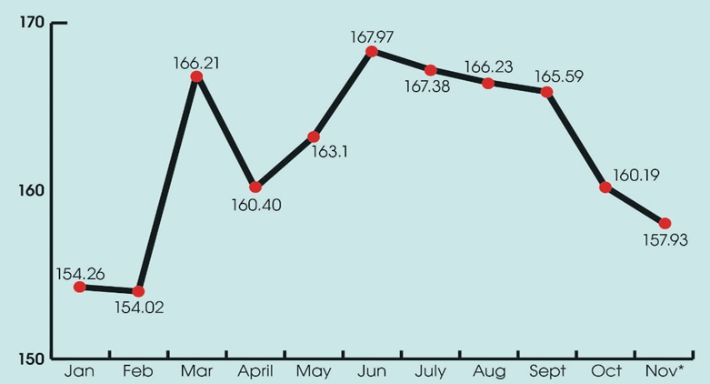
Figure 1. Exchange rate of PKR to USD for 2020
This will help different firms and business owners to take informed decisions regarding investments as well as debts.
II. literature review

Extensive literature exists on studying and predicting exchange rate volatility of PKR against US dollars.
Asadullah et.al. have conducted research using ARIMA model to predict the exchange rate of PKR and USD dollars in future. The study presents data over a timeline of five years depicting the forecasted and actual values. The implemented model presented very close forecasted and actual values with a difference of less than 1%. The research entails sufficient evidence to prove ARIMA method as a potential candidate for government authorities, stakeholders, and policymakers to adopt for predicting the future trends of exchange rate wisely [1]. In another study, Farzana focused on determining the scope and tendency of exchange rate volatility and its influence on the macroeconomic capacity of Pakistan. The study also presents the exchange rate of US dollars and Pakistani rupee in context of import and export balance of Pakistan, and inflation rate through regression techniques such as ANOVA. The study analysis included statistics from 2000 -2010, and research results validated a significant influence of annual imports and inflation rate on the exchange rate. [2].
Ayub has reported exchange rate volatility of Pakistani currency against five currencies by making use of advanced time series econometric models. The research employed the daily data of ten years to analyze the risk-averse approach of stakeholders in the foreign exchange market. The short-term elements that have played role in destabilizing the PKR against foreign currencies have been highlighted along with recommendations to mitigate it [3].
Rabab et.al. addressed the application and effectiveness of Value-at-Risk (VaR) models in the context of foreign exchange risk evaluation. The paper presented VaR model based on extreme value theory indicating a better risk assessment of Pakistani rupee, against US dollar and Euro, through this approach. The focus was to study differential managing of the Pakistani rupee against US dollar and Euro. It had been emphasized that the model is adaptable for the changing markets, and therefore, can result in less severe losses as compared to static models [4]. In another research, Imran investigated the potential macroeconomic factors that influence the Pakistani currency; rupee. The research presents augmented Dickey Fuller tests to analyse the broad data range from the year 1991 to 2014. Johansen co-integration was implemented to determine the long-term relation among the variables, and to quantify the relation among dependent and independent variables, regression analysis was done. The study results revealed a significant impact of export, inflation, and interest [5].

III. Mathematical Model
In our model, we assume that the exchange rate of PKR to USD is dependent on time only. To model the exchange rate with respect to time, we have employed the logistic growth model extended as dynamic logistic growth model. We assume that the growth of exchange rate in time can be characterized by a logistic model along with dynamic integration to develop an accurate model. The logistic growth model considers the exchange rate and the velocity of change in exchange rate respectively.
The dynamic model is characterized by the following non-linear ordinary differential equation.

Where Ex (t) represents the exchange rate at time t. Equation 1 can be rewritten as:-

Equation 2 shows the model equation rearranged in the form of logistic growth model. Now, as the exchange rate varies dynamically in real time, we can safely assume that and stay constant for a short time period. With that, the equation can be parameterized as the differential equation:-

Where < , and , are values of two points in time.
Now if we let,

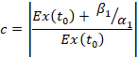

then the solution is:-

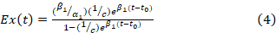

if > ,

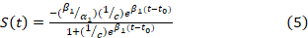

if > ,

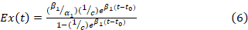

if < ,

if < ,

The logistic model characterized by equation 1 characterizes the exchange rate with the variable Ex (t) and its rate of change with dEx (t)/dt. This model also accurately quantifies the dynamic changes that occur in the exchange rate and it caters phenomenon such as mean reversion as well. Equation 4, 5, 6 and 7 characterize the process of mean reversion i.e. the exchange rate can be settled towards an equilibrium point depending on the current value.
However, in the case of exchange rate of PKR with USD, and its history with time, it is observed that there is increase in the rate most of the times. Therefore, we don’t need to consider the equilibrium point or mean reversion. Equation 4 of this model is characterized as our actual model where we assume that exchange rate increases with time. This greatly simplifies our model and accurately predicts the price of PKR against USD. To apply the model, the model is discretised and converted to difference equation between two time points, t0 and t1. In this way the equation becomes implementable and easy to comprehend.
Other models discussed in the reference paper include dynamic transformed logistic model which takes the velocity as well as acceleration of exchange rate into account. It is a second order differential equation model. It also has the property to cater mean reversion however that is not required in our case.
The third model discussed in the reference paper is the dynamic relative growth rate transformed logic which takes the relative rate into account. This model also depicts logistic growth with the difference that it considers relative growth. The fourth model is the dynamic general model which has a single dynamically varying constant.

IV. Numerical Results & Discussion

In order to produce an accurate and effective model, data of exchange rate of PKR to USD was collected for the previous 15-20 years. The trend in Figure. 1 shows that the PKR has constantly depreciated against the USD.
Using this data, we tuned the parameters of our model in equation 4 which is the simplified and discretized model for the exchange rate. The two parameters required to be tuned are alpha and beta which are dynamic but we assume that they constant for a short interval of time. This simplifies our model and the tuning process.
To tune the model, I took the value of exchange rate on July 31, 2021 as the exchange rate at time t0. The values of alpha and beta were tuned by hit and trial to achieve results as accurate as possible. For the first model, the parameter beta was chosen to be 0.001 and alpha was set to 1*10^-4. The results of the model are shown in Figure. 3. Point 0 on x-axis marks as the value on July 31, 2021. The time in negative refers to months before this date and the time in positive shows months after this time.
The model in Figure. 3 didn’t shown a good performance as it showed an exchange rate of less than 50 in the start
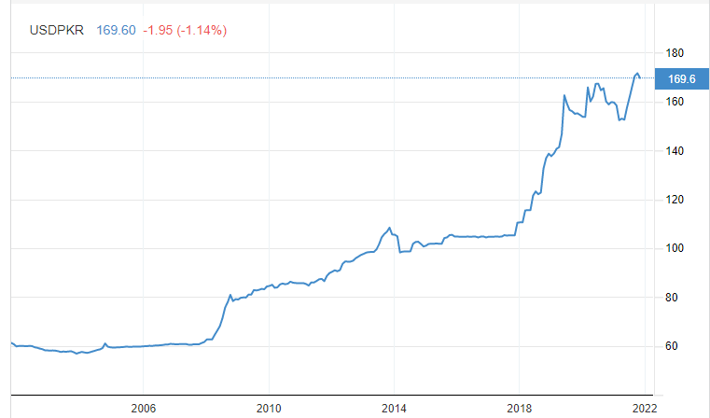
Figure 2. Exchange rate of PKR to USD since 2002

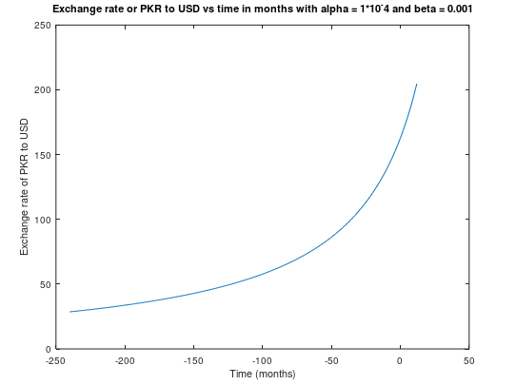
Figure 3. Exchange rate for alpha = 1*10^-4 and beta = 0.001
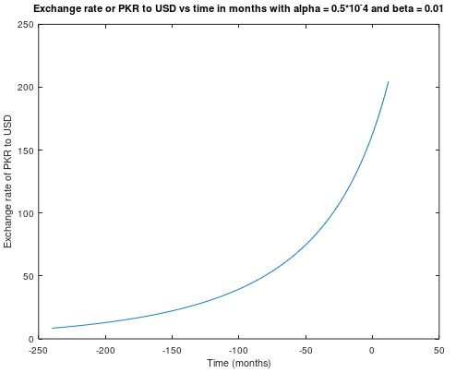
Figure 4. Exchange rate for alpha = 0.5*10^-4 and beta = 0.01
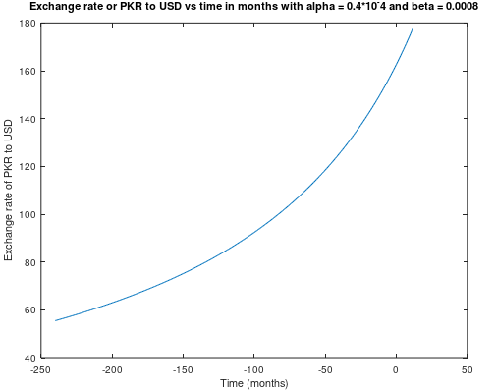
Figure 5. Exchange rate for alpha = 0.4*10^-4 and beta = 0.0008
whereas the actual rate lies somewhere around 60 in the region of years 2002 to 2007.
The model was further tuned b increasing beta. The second model is shown in Figure. 4. Increasing beta caused more problems for us as it has led to a deceasing curve for the initial years. This led us to further tuning the value of alpha and beta until we achieve accurate results for presentation.
The final model was tuned with beta = 0.008 and alpha = 0.0002. This model is shown in Figure. 5. This model shows relatively good results starting around with an exchange rate of 60 in the initial years. It accurately captures the rising curve of the exchange rate in the recent years and it predicts an exchange rate of approximately 178 in 30 June, 2022. The model gives an accurate prediction of the values as many international economic institutions have predicted the exchange rate in 2022 to be around 180. Additionally, the model has been tuned in a way to accommodate the sudden surges in the exchange rate as experienced in the recent years and months. The model chosen works in a way that the parameter alpha controls the starting value of the curve as we have seen that a lower value of alpha resulted in the curve starting from a higher value. The parameter beta controls the sharp and exponential rise of the curve. Lower beta correctly and accurately accommodates the surges in the exchange rate of PKR with respect to USD. Table. 1 below shows the comparison of the predicted values vs actual values by our model.
Table 1. Comparison of predicted results with actual results
Year | Predicted exchange rate | Actual exchange rate
2012 | 91.7 | 90.1
2014 | 97.66 | 99.9
2016 | 98.94 | 106
2018 | 103.26 | 114
2020 | 145.35 | 145.65
2021 | 170.35 | 170.65

V- Recommendations
The results section discusses the final model designed in detail along with its parameters and predicted values. I would highly recommend this model to be used for predictions as this model accurately captures the rapidly changing exchange rate of PKR with USD in the recent times. The model shows high accuracy with an error less than 1% with the actual values for the year 2021. Additionally, the prediction by the model for the upcoming year i.e. 2022 is good enough as it considers most of the factors that are changing with time.
In future, to make predictions even better, this model can be combined with some additional model and the values maybe average to make an even stronger assessment of the exchange rate in the future. A neural network based model can be designed and employed in parallel to this network. Neural network based models are quite accurate in time series data prediction. Combined, these two models can be very effective and accurate in predicting the upcoming exchange rate values.
VI- Acknowledgement

Hereby, I would like to extend my gratitude and regards to the instructor as well as the organization for providing me with the opportunity and the resources to execute this project. I would also like to thank the organization for arranging the course for me to help me explore the different techniques that are used in the domain of mathematical modelling and data in general.

REFERENCES

[1] | N. A. M. J. P. L. D.-S. Muhammad Asadullah, "Forecast Foreign Exchange Rate: The Case Study of PKR/USD," Mediterranean Journal of Social Sciences, 2020.
[2] | F. Shaheen, "Fluctuations in Exchange Rate and its Impact on Macroeconomic Performance of Pakistan".
[3] | M. A. Siddiqui, "Modelling Pak Rupee Volatility against Five Major Currencies in the Perspective of Different Exchange Rate Regimes," European Journal of Economics, Finance and Administrative Sciences, 2009.
[4] | J. Y. U. K. Z. I. N. G. U. D. S. Syeda Rabab Mudakkar, "Foreign exchange risk in a managed float regime: A case study of Pakistani rupee," The International Journal of Theoretical and Applied Papers on Economic Modelling, 2013.
[5] | I. Khan, "Factors effecting exchange rate: a case of Pakistan," Munich Personal RePEc Archive (MPRA), 2016.

